Heritage University 04-1-24

Mathematics and Computer Science Dept. due: 04-7-24

DatabaseII

Homework 7

*( MongoDB, MySQL,PHP )*

1.Consider the data (inventory):

|  |  |  |  |
| --- | --- | --- | --- |
| item | qty | tags | dim |
| periodical | 30 | “red”,”green” | 15,21 |
| books | 50 | “red”,”blank”,”blue” | 16,21 |
| pens | 20 | “red”,”blank” | 15,30 |
| pensils | 34 | “blank”,”red: | 23,40 |

(1) prepare the collection: ”inventory”

use HW7Q1;

db.createCollection("inventory");

db.inventory.insertMany([{item:'periodical', qty:30, tags:["red", "green"], dim: [15, 21]},

{item: 'books', qty:50, tags:["red", "blank", "blue"], dim: [16, 21]},

{item:'pens', qty:20, tags:["red", "blank"], dim:[15, 30]},

{item:"pencils", qty:34, tags:["blank", "red"], dim:[23, 40]}]);

(2) give the items that have tags:red, blank (1st red,2nd blank)

db.inventory.find({tags: ['red', 'blank']})

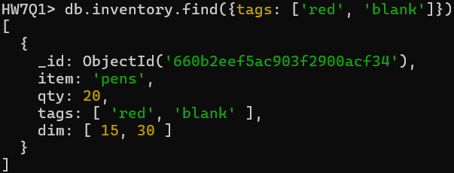

(3)give the items that have tags:red, blank (without order)

db.inventory.find({tags: {$all : ['red', 'blank']}})

(4)find the items that have in dim at least value > 20

db.inventory.find({dim: {$lt : 20}})

(5) find the documents where dim items have at least one element that is greater than 16 and less that 30

db.inventory.find({dim: { $elemMatch : {$gt : 16, $lt : 30}}})

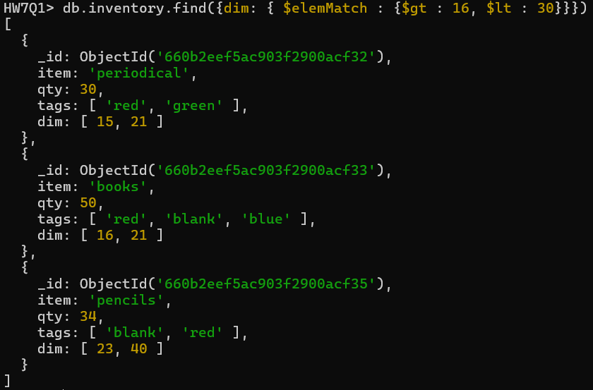

(6) find documents where the second element of dim is greater than 30

db.inventory.find({'dim.1': { $gt : 30}})

(7) find the documents where the size of the array tag is 3

db.inventory.find({tags : { $size : 3}})

(8) find the items with qty > 20 in sorting order

db.inventory.find({qty: {$gt: 20}}).sort({qty:1})

(9) find the sum of the “qty”

db.inventory.aggregate([ { $group: { _id: null, sumOfQty: { $sum: "$qty" }}}, { $project : { _id: 0, sumOfQty : 1}}])



2. Consider the data (game):

|  |  |  |  |  |  |
| --- | --- | --- | --- | --- | --- |
| name | age |  | Score 1 | Score 2 | Score 3 |
| peter | 20 |  | 4 | 6 | 5 |
| paul | 22 |  | 10 | 4 | 6 |
| jim | 25 |  | 5 | 10 | 7 |
| george | 19 |  | 3 | 9 | 8 |

(1) prepare the collection: ”games”

use HW7Q2;

db.createCollection("games");

db.games.insertMany([{name:"peter", age:20, Score1: 4, Score2: 6, Score3: 5}, {name:"paul", age:22, Score1: 10, Score2: 4, Score3: 6}, {name:"jim", age:25, Score1: 5, Score2: 10, Score3: 7}, {name:"george", age:19, Score1: 3, Score2: 9, Score3: 8}]);

(2) get all the documents with scores: one:4, two:6, three:5

db.game.find({Score1:4, Score2:6, Score3:5});

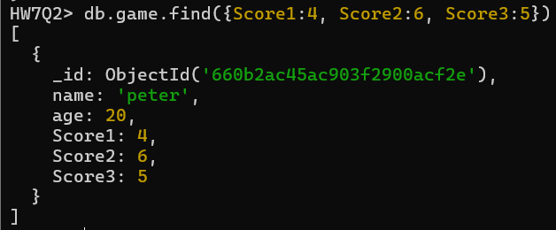

(3) find the player that has score in the third game =7

db.game.find({Score3:5})

(4) find the player that has scores less than 5 in the first game

db.game.find({Score1:{$lt: 5}})

(5) find the players that has scores less than 5 in the first game and age = 19

db.game.find({$and: [{Score1:{$lt: 5}}, {age:19}]})

**3.** Consider a database "nwords" with the collection "nword_stats".

A document "tweet" has the follwing structure: (consider size:4)

word: tweet, first: 't',last:'t',

size : 3, letters" : "t", "w", "e",

stats : vowels : 2, consonants : 3,

charsets : type : consonants, chars : t, w ,

type : vowels, chars : e .

category : new

please do the following:

a. According to that description prepare the document "google" (consider size:4)

{

'word' : 'google',

'first': 'g',

'last' : 'e',

'size' : 4,

'letters' : ['g', 'o', 'l', 'e'],

'stats' : [

{ 'vowels' : 3},

{'consonants' : 3}

],

'charsets' : [

{'type' : 'consonants', 'chars' : ['g', 'l']},

{'type' : 'vowels', 'chars' : ['o', 'e']}

],

'category' : 'old'

}

b. insert the two documents into collection "nwords_stats using Javascript and print the value of the word for both documents (d_add.js)

**CODE:**

var nword_values = [

    {

        'word' : 'tweet',

        'first': 't',

        'last' : 't',

        'size' : 3,

        'letters' : ['t', 'w', 'e'],

        'stats' : [

            {

                'vowels' : 2

            },

            {

                'consonants' : 3

            }

        ],

        'charsets' : [

            {

                'type' : 'consonants',

                'chars' : ['t', 'w']

            },

            {

                'type' : 'consonants',

                'chars' : ['e']

            }

        ],

        'category' : 'new'

    },

    {

        'word' : 'google',

        'first': 'g',

        'last' : 'e',

        'size' : 4,

        'letters' : ['g', 'o', 'l', 'e'],

        'stats' : [

            {

                'vowels' : 3

            },

            {

                'consonants' : 3

            }

        ],

        'charsets' : [

            {

                'type' : 'consonants',

                'chars' : ['g', 'l']},

            {

                'type' : 'vowels',

                'chars' : ['o', 'e']

            }

        ],

        'category' : 'old'

    }

];

console.log("First word is " + nword_values[0]['word']);

console.log("Second word is " + nword_values[1]['word']);

db.nword_stats.insertMany(nword_values);

**OUTPUT:**

c. give a proof of insertion of the two documents in the collection.

d. change the size for "tweet" from 3 to 5 and for "google" from 4 to 6.

db.nword_stats.updateOne({word:'tweet'},{$set : {size : 5}})

db.nword_stats.updateOne({word:'google'},{$set : {size : 6}})

e. show the data with the new size.

db.nword_stats.find()

4. A web application for books is considered with the following requirements:

a.database: booksdb , table: booksdb

b.the user insert the first three records with PHP

c. a menu with choices using MySQL,PHP: insert (with prepared statement) and list all

Consider also validation for the form

d. Start with: start_books3.html (menu). Additional operations might be needed for the application (change -peter to paul- , delete -ann-).

Hint: please try to avoid using the isbn for the additional operations. The menu should include all the operations (insert, display, change, delete).

data:

|  |  |  |  |
| --- | --- | --- | --- |
| isbn | author | title | price |
| 333586 | peter | MathI | 20 |
| 358769 | ann | Physics | 25 |
| 453967 | karl | Topology | 30 |

**CODE: start3_books3.html**

<!DOCTYPE HTML>

<html lang="en">

<head>

    <meta charset="UTF-8">

    <title>Book Application</title>

</head>

<body>

<h1>Web Application for Books</h1>

<p>Make Your Selection:</p>

<p><a href="insert_books.php">Insert Books</a></p>

<p><a href="display_books.php">Display Books</a></p>

<p><a href="change_books.php">Update Book</a></p>

<p><a href="delete_books.php">Delete Book</a></p>

</body>

</html>

**Output:start3_books3.html**

**Code: insert_books.php**

<!DOCTYPE HTML>

<html lang="en">

<head>

    <meta charset="UTF-8">

    <title>Insert Books</title>

</head>

<body>

<h1>Enter a Book</h1>

<form action="insert_books.php" method="post">

<p><label>ISBN <input type="number" name="ISBN" min="100000" max="999999" autocomplete="off"></label></p>

<p><label>Author <input type="text" name="author" size="10" maxlength="30" autocomplete="off"></label></p>

<p><label>Title <input type="text" name="title" size="15" maxlenght="30" autocomplete="off"></label></p>

<p><label>Price <input type="number" name="price" min="1" max="10000" autocomplete="off"></label></p>

<p><input type="submit" name="Submit" value="Enter"></p>

</form>

<?php

    include("createDatabase.php");

    $errors = []; //intialize error array

    //make connnect to the database

    $dbc = @mysqli_connect("localhost", 'root', '', 'booksdb') OR die('Could not connect MySQL: ' . mysqli_connect_error() );

    //if post is submitted

    if ($_SERVER["REQUEST_METHOD"] == "POST") {

        if (empty($_POST["ISBN"])){ //if name was empty

            $errors = "ISBN is required";

        }

        if (empty($_POST["author"])){ //if message was empty

            $errors = "author is required";

        }

        if (empty($_POST["title"])){ //if name was empty

            $errors = "title is required";

        }

        if (empty($_POST["price"])){ //if message was empty

            $errors = "price is required";

        }

        if (empty($errors)){

            $stmt = mysqli_prepare($dbc, "INSERT INTO books (isbn, author, title, price) VALUES (?, ?, ?, ?)");

            //bind parameters

            mysqli_stmt_bind_param($stmt, "ssss", $ISBN, $author, $title, $price);

            //Set parameters and execute

            $ISBN = mysqli_real_escape_string($dbc, strtolower(trim($_POST['ISBN'])));

            $author = mysqli_real_escape_string($dbc, strtolower(trim($_POST['author'])));

            $title = mysqli_real_escape_string($dbc, trim($_POST['title']));

            $price = mysqli_real_escape_string($dbc, strtolower(trim($_POST['price'])));

            //execute statement

            if (mysqli_stmt_execute($stmt)) {

                echo "New record inserted successfully</br>";

            } else {

                echo "Error: " . mysqli_error($dbc);

            }

            // Close statement

            mysqli_stmt_close($stmt);

        }

    }

    //close connecition

    mysqli_close($dbc);

    // Display errors from NULL values

    if (!empty($errors)) {

        echo "<h3>Error List:</h3>";

        echo "<ul>";

        foreach ($errors as $error) {

            echo "<li>$error</li>";

        }

        echo "</ul>";

    }

//gives you link to return to start_books3.html

echo '<p align="center"><a href="start_books3.html">Return to Selection Menu</a></p>';

?>

</body>

</html>

**Output: insert_books.php**

**CODE: display_books.php**

<?php

function displayQuery($option = "") {

    $query = "";

    switch ($option) {

        case "name_asc":

            $query = "SELECT * FROM books ORDER BY author ASC";

            break;

        case "title_desc":

            $query = "SELECT * FROM books ORDER BY author DESC";

            break;

        case "title_asc":

            $query = "SELECT * FROM books ORDER BY title ASC";

            break;

        case "price_desc":

            $query = "SELECT * FROM books ORDER BY title DESC";

            break;

        case "price_asc":

            $query = "SELECT * FROM books ORDER BY price ASC";

            break;

        case "isbn_desc":

            $query = "SELECT * FROM books ORDER BY isbn DESC";

            break;

        case "isbn_asc":

            $query = "SELECT * FROM books ORDER BY isbn ASC";

            break;

        default:

            $query = "SELECT * FROM books ORDER BY author DESC";

            break;

    }

    return $query;

}

?>

<!DOCTYPE HTML>

<html lang="en">

<head>

    <meta charset="UTF-8">

    <title>Display Books</title>

</head>

<body>

<h1>Display Books</h1>

<form action="display_books.php" method="post">

<p><label>Options</label>

<select name="display">

<option value="name_desc" <?php if (isset($_POST["display"]) && $_POST['display'] == 'name_desc') echo 'selected="selected"';?>>Author A-Z</option>

<option value="name_asc" <?php if (isset($_POST["display"]) && $_POST['display'] == 'name_asc') echo 'selected="selected"';?>>Author Z-A</option>

<option value="title_desc" <?php if (isset($_POST["display"]) && $_POST['display'] == 'title_desc') echo 'selected="selected"';?>>Title A-Z</option>

<option value="title_asc" <?php if (isset($_POST["display"]) && $_POST['display'] == 'title_asc') echo 'selected="selected"';?>>Title Z-A</option>

<option value="price_desc" <?php if (isset($_POST["display"]) && $_POST['display'] == 'price_desc') echo 'selected="selected"';?>>Price Descreasing</option>

<option value="price_asc" <?php if (isset($_POST["display"]) && $_POST['display'] == 'price_asc') echo 'selected="selected"';?>>Price Increasing</option>

<option value="isbn_desc" <?php if (isset($_POST["display"]) && $_POST['display'] == 'isbn_desc') echo 'selected="selected"';?>>ISBN Decreasing</option>

<option value="isbn_asc" <?php if (isset($_POST["display"]) && $_POST['display'] == 'isbn_asc') echo 'selected="selected"';?>>ISBN Increasing</option>

</p><p><input type="submit" name="Submit" value="Select"></p>

<?php

include("createDatabase.php");

//make connnect to the database

$dbc = @mysqli_connect("localhost", 'root', '', 'booksdb') OR die('Could not connect MySQL: ' . mysqli_connect_error() );

//make query

if (isset($_POST["display"]) && !empty($_POST["display"]))

    $query = displayQuery($_POST["display"]);

else

    $query = "SELECT * FROM books";

//execute query and get results

$result = mysqli_query($dbc, $query);

$num = mysqli_num_rows($result);

if ($num > 0){

    // creates table header

    echo '<table align="center" width=”60%” cellpadding="10">

    <thead>

    <tr align="center">

    <th align="center">ISBN</th>

    <th align="center">author</th>

    <th align="center">title</th>

    <th align="center">price</th>

    </tr>

    </thead>

    <tbody>';

    //fetch and display all data in tables

    while ($row = mysqli_fetch_assoc($result)){

        echo '<tr><td align="center">' . $row['isbn'] .

        '</td><td align="center">' . $row['author'] .

        '</td><td align="center">' . $row['title'] .

        '</td><td align="center">' . $row['price'] .

        '</td></tr>';

    }

    //close the table

    echo '</tbody><table>';

    mysqli_free_result($result); //free up space

} else if ($num == 0) { //empty result

    echo '<p align="center">No Results</p>';

    mysqli_free_result($result);

} else { //it it failed

    //message to user

    echo '<p class="error"><strong>Query failed.</strong></p>';

    //debug message

    echo '<p>' . mysqli_error($dbc) . '<br><br>Query: ' . $query . '</p>';

}

mysqli_close($dbc);

//gives you link to return to start_books3.html

echo '<p align="center"><a href="start_books3.html">Return to Selection Menu</a></p>';

?>

</form>

</body>

</html>

**Output: display_books.php**

**Code: change_books.php**

<!DOCTYPE HTML>

<html lang="en">

<head>

    <meta charset="UTF-8">

    <title>Update Books</title>

</head>

<body>

<?php

include("createDatabase.php");

//make connnect to the database

$dbc = @mysqli_connect("localhost", 'root', '', 'booksdb') OR die('Could not connect MySQL: ' . mysqli_connect_error() );

$query = "SELECT * FROM books";

//execute query and get results

$result = mysqli_query($dbc, $query);

$num = mysqli_num_rows($result);

if ($num > 0){

    $errors = []; // Initialize an empty array to store errors

    // Check if the form has been sumbitted:

    if ($_SERVER['REQUEST_METHOD'] == 'POST') {

        mysqli_free_result($result); //free up space

        if (empty($_POST["ISBN"]) && !isset($_POST["ISBN"])){ //if name was empty

            $errors[] = "ISBN is required";

        }

        if (empty($_POST["author"]) && !isset($_POST["author"])){ //if message was empty

            $errors[] = "author is required";

        }

        if (empty($_POST["title"]) && !isset($_POST["title"])){ //if name was empty

            $errors[] = "title is required";

        }

        if (empty($_POST["price"]) && !isset($_POST["price"])){ //if message was empty

            $errors[] = "price is required";

        }

        if (empty($errors)) { // if there are no errors

            $stmt = mysqli_prepare($dbc, "UPDATE books SET author=?, title=?, price=? WHERE isbn=?");

            //bind parameters

            mysqli_stmt_bind_param($stmt, "ssss", $author, $title, $price, $ISBN);

            //Set parameters and execute

            $author = mysqli_real_escape_string($dbc, strtolower(trim($_POST['author'])));

            $title = mysqli_real_escape_string($dbc, trim($_POST['title']));

            $price = mysqli_real_escape_string($dbc, strtolower(trim($_POST['price'])));

            $ISBN = mysqli_real_escape_string($dbc, strtolower(trim($_POST['ISBN'])));

            //execute statement

            if (mysqli_stmt_execute($stmt)) {

                mysqli_stmt_close($stmt); // Close statement

                $result = mysqli_query($dbc, $query);

                $num = mysqli_num_rows($result);

                echo '<h1>Update a Book</h1>

                <form action="change_books.php" method="post">';

                while ($row = mysqli_fetch_assoc($result))

                    echo "<p><input type=\"radio\" name=\"ISBN\" value=\"". $row['isbn'] . "\">" . "Title: " . $row['title'] . "</p><p>&emsp;Author: " . $row['author'] . "</p><p>&emsp;Price: " . $row["price"] . "</p>";

                echo'<p><label>Author <input type="text" name="author" size="10" maxlength="30" autocomplete="off"></label></p>

                <p><label>Title <input type="text" name="title" size="15" maxlenght="30" autocomplete="off"></label></p>

                <p><label>Price <input type="number" name="price" min="1" max="10000" autocomplete="off"></label></p>

                <p><input type="submit" name="Submit" value="Enter"></p>

                </form>';

                echo "New record updated successfully</br>";

            } else {

                echo "Error: " . mysqli_error($dbc);

            }

        } else { //Report the errors.

            echo "<h3>Error List:</h3>";

            echo "<ul>";

            foreach ($errors as $error) {

                echo "<li>$error</li>";

            }

            echo "</ul>";

        }

    }

    else

    {

        echo '<h1>Update a Book</h1>

                <form action="change_books.php" method="post">';

        while ($row = mysqli_fetch_assoc($result))

            echo "<p><input type=\"radio\" name=\"ISBN\" value=\"". $row['isbn'] . "\">" . "Title: " . $row['title'] . "</p><p>&emsp;Author: " . $row['author'] . "</p><p>&emsp;Price: " . $row["price"] . "</p>";

        echo'<p><label>Author <input type="text" name="author" size="10" maxlength="30" autocomplete="off"></label></p>

        <p><label>Title <input type="text" name="title" size="15" maxlenght="30" autocomplete="off"></label></p>

        <p><label>Price <input type="number" name="price" min="1" max="10000" autocomplete="off"></label></p>

        <p><input type="submit" name="Submit" value="Enter"></p>

        </form>';

        mysqli_free_result($result); //free up space

    }

} else if ($num == 0) { //empty result

    echo '<p align="center">Nothing to Update, Please Enter Some Books.</p>';

    mysqli_free_result($result);

} else { //it it failed

    //message to user

    echo '<p class="error"><strong>Query failed.</strong></p>';

    //debug message

    echo '<p>' . mysqli_error($dbc) . '<br><br>Query: ' . $query . '</p>';

}

mysqli_close($dbc);

//gives you link to return to start_books3.html

echo '<p align="center"><a href="start_books3.html">Return to Selection Menu</a></p>';

?>

</body>

</html>

**Output: change_books.php**

**Code:delete_books.php**

<!DOCTYPE HTML>

<html lang="en">

<head>

    <meta charset="UTF-8">

    <title>Delete Books</title>

</head>

<body>

<?php

include("createDatabase.php");

//make connnect to the database

$dbc = @mysqli_connect("localhost", 'root', '', 'booksdb') OR die('Could not connect MySQL: ' . mysqli_connect_error() );

$query = "SELECT * FROM books";

//execute query and get results

$result = mysqli_query($dbc, $query);

$num = mysqli_num_rows($result);

if ($num > 0){

    $errors = []; // Initialize an empty array to store errors

    // Check if the form has been sumbitted:

    if ($_SERVER['REQUEST_METHOD'] == 'POST') {

        if (empty($_POST["ISBN"]) && !isset($_POST["ISBN"])){ //if name was empty

            $errors[] = "Selection is required";

        }

        if (empty($errors)) { // if there are no errors

            $stmt = mysqli_prepare($dbc, "DELETE FROM books WHERE isbn=?");

            //bind parameters

            mysqli_stmt_bind_param($stmt, "s", $ISBN);

            $ISBN = mysqli_real_escape_string($dbc, strtolower(trim($_POST['ISBN'])));

            //execute statement

            if (mysqli_stmt_execute($stmt)) {

                mysqli_stmt_close($stmt); // Close statement

                $query = "SELECT * FROM books";

                //execute query and get results

                $result = mysqli_query($dbc, $query);

                $num = mysqli_num_rows($result);

                echo '<h1>Enter a Book</h1>';

                echo '<form action="delete_books.php" method="post">';

                while ($row = mysqli_fetch_assoc($result))

                    echo "<p><input type=\"radio\" name=\"ISBN\" value=\"". $row['isbn'] . "\">" . "Title: " . $row['title'] . "</p><p>&emsp;Author: " . $row['author'] . "</p><p>&emsp;Price: " . $row["price"] . "</p>";

                mysqli_free_result($result); //free up space

                echo'<p><input type="submit" name="Submit" value="Delete"></p></form>';

                echo "Record deleted successfully</br>";

            } else {

                echo "Error: " . mysqli_error($dbc);

            }

        } else { //Report the errors.

            echo "<h3>Error List:</h3>";

            echo "<ul>";

            foreach ($errors as $error) {

                echo "<li>$error</li>";

            }

            echo "</ul>";

        }

    }

    else

    {

        echo '<h1>Enter a Book</h1>';

        echo '<form action="delete_books.php" method="post">';

        while ($row = mysqli_fetch_assoc($result))

            echo "<p><input type=\"radio\" name=\"ISBN\" value=\"". $row['isbn'] . "\">" . "Title: " . $row['title'] . "</p><p>&emsp;Author: " . $row['author'] . "</p><p>&emsp;Price: " . $row["price"] . "</p>";

        mysqli_free_result($result); //free up space

        echo'<p><input type="submit" name="Submit" value="Delete"></p></form>';

    }

} else if ($num == 0) { //empty result

    echo '<p align="center">Nothing to Delete, Please Enter Some Books.</p>';

    mysqli_free_result($result);

} else { //it it failed

    //message to user

    echo '<p class="error"><strong>Query failed.</strong></p>';

    //debug message

    echo '<p>' . mysqli_error($dbc) . '<br><br>Query: ' . $query . '</p>';

}

mysqli_close($dbc);

//gives you link to return to start_books3.html

echo '<p align="center"><a href="start_books3.html">Return to Selection Menu</a></p>';

?>

</body>

</html>

**